23CSE111 OBJECT ORIENTED PROGRAMMING
S2 B.Tech CSE
Department of Computer Science and Engineering
Amrita School of Computing, Amritapuri Campus
CASE STUDY
PHASE – 2 (Design)
Architectural Modelling(CO2)

Group No : D1
Team Members :
Roll No | Student Name
AM.SC.U4CSE25304 | Arav D A
AM.SC.U4CSE25306 | Avinash Menon
AM.SC.U4CSE25310 | Boomish Saravanan
AM.SC.U4CSE25311 | Chevuru Neekshitha

- Problem Title : School Fee Management System

STRUCTURAL DESIGN
2. Class Diagram

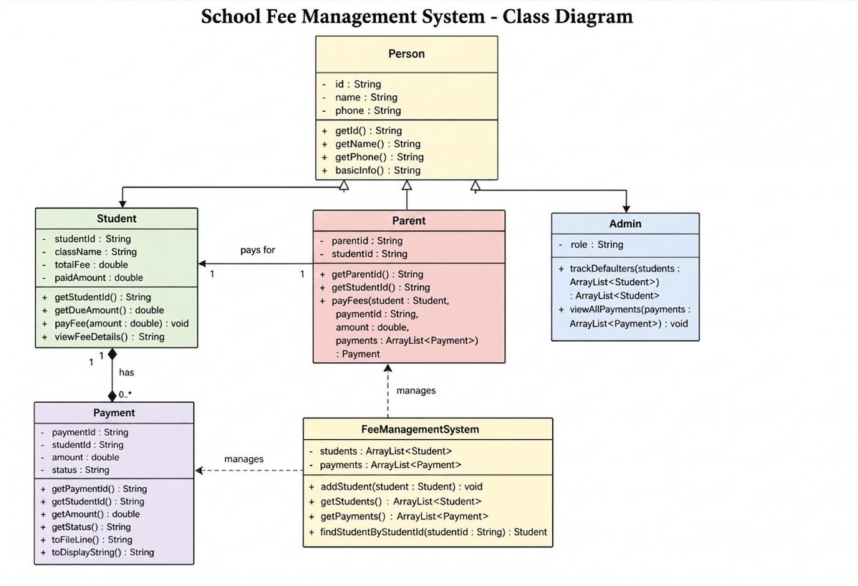

BEHAVIUORAL DESIGN
3. Use-case diagram
- List of actors
- Parent
- Student
- Admin
- List of use-cases
1. Add Student
Admin enters student details such as ID, name, class, and total fee to register a new student in the system.
2. View Students
Admin can view all registered students along with their fee details including total, paid, and due amounts.
3. Make Payment
Parent enters student ID and payment details to pay fees. The system updates the student’s paid amount and records the transaction.
4. Generate Receipt
After a successful payment, the system generates a digital record and saves the payment details into a file (payments.txt).
5. View Payments
Admin can view all payment transactions stored in the system.
6. Track Defaulters
Admin checks and identifies students who still have pending fees (due amount > 0).
c. Use case diagram (use UML notations)
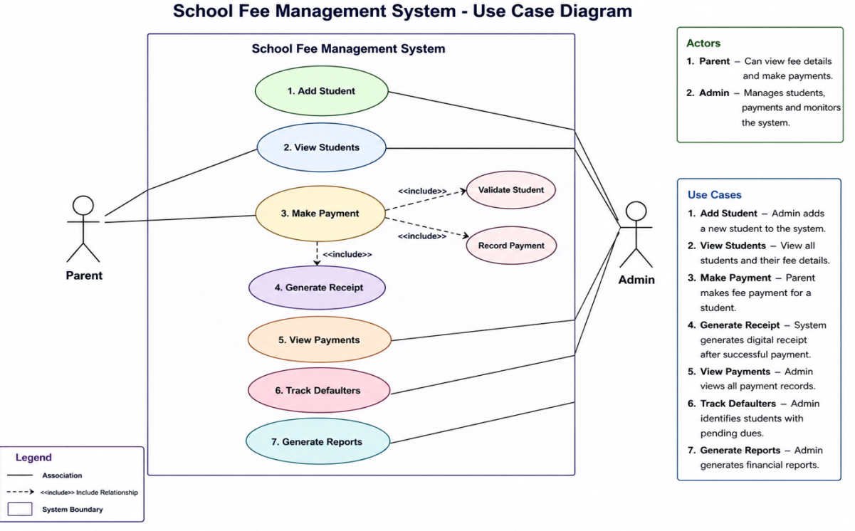

- Sequence diagram(use UML notations)
  - Use Case : Make Payment

Scenario Description:
A parent wants to pay the school fee for their child. The parent enters the student ID and payment details. The system verifies the student, updates the paid amount, records the payment, and saves it to a file. Finally, a confirmation (receipt) is shown.
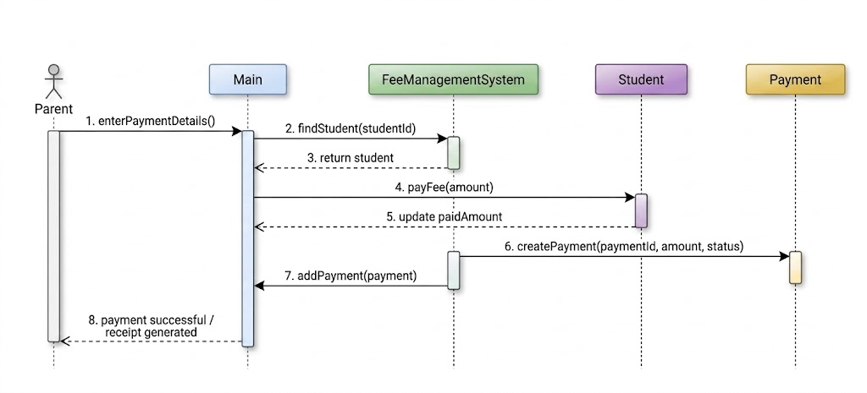
  - Use Case: Send Reminder & Track Defaulters

Scenario Description:
The admin wants to identify students who have not paid their fees completely. The system retrieves all students, checks their due amounts, and lists those with pending fees.
